Auto Increase / Decrease server count based on CPU consumption via ASG
We can increase / Decrease Server count based on cpu/disk/memory consumption ,traffics to the Load balancer . then the LB will tell the ASG to deploy or terminate the servers in a specific Availability zone and subnets.
Prerequisite :-
VPC
4 subnets
one or two public subnets (one bastion host)
2 private subnet( initially one pvt server name Flipkart , in which nginx service should run on port 80)
One Launch Template of Server named Fliipart .(AMI +LT).
One Target group (TG-flipkart-nginx) in which all the server will run (should configured in port 80 and default path)
Create a ALB (Load Balancer HTTP protocol and port 80).
Connect the ALB to TG(TG-flipkart-nginx).
User the ALB DNS to check if the nginx service running on pvt server (Flipkart ). The home page should come automatically .

Now Configure ASG to increase and decrease the server count based on cpu consumtion (CPU >1%)

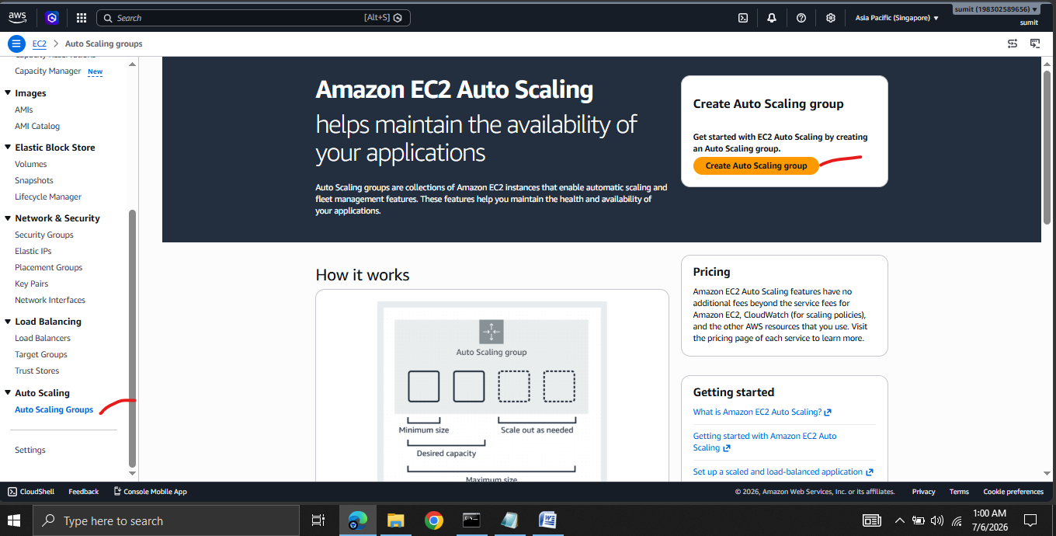
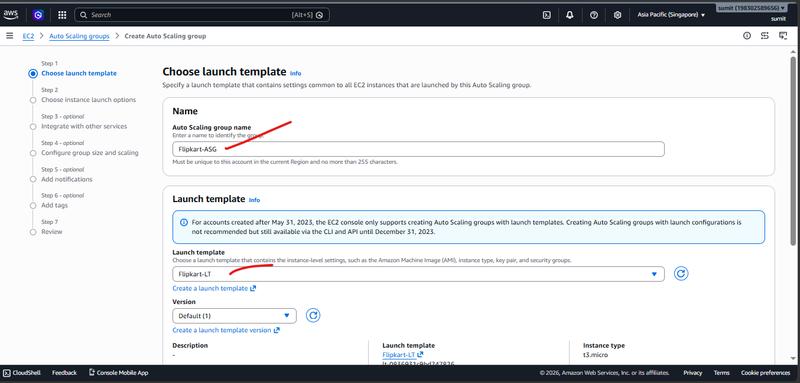
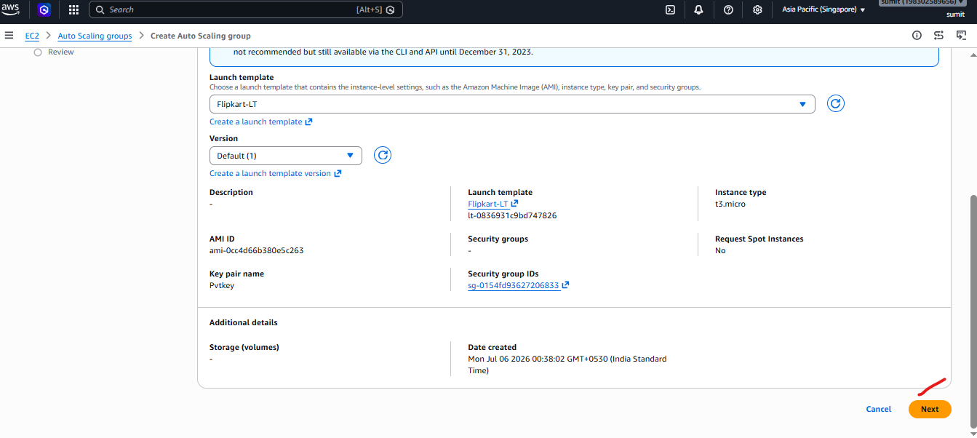
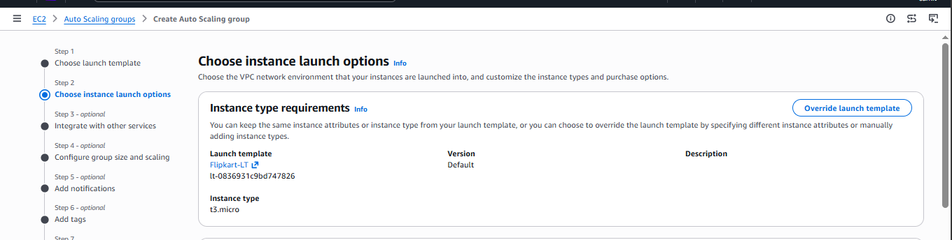
Select the Desired VPC and select the subnets in which you want ASG to deploy the servers.
We should select balanced best effort cause if one AZ failed it will not waste time in validating again and again . I will host the servers on healthy AZs only.
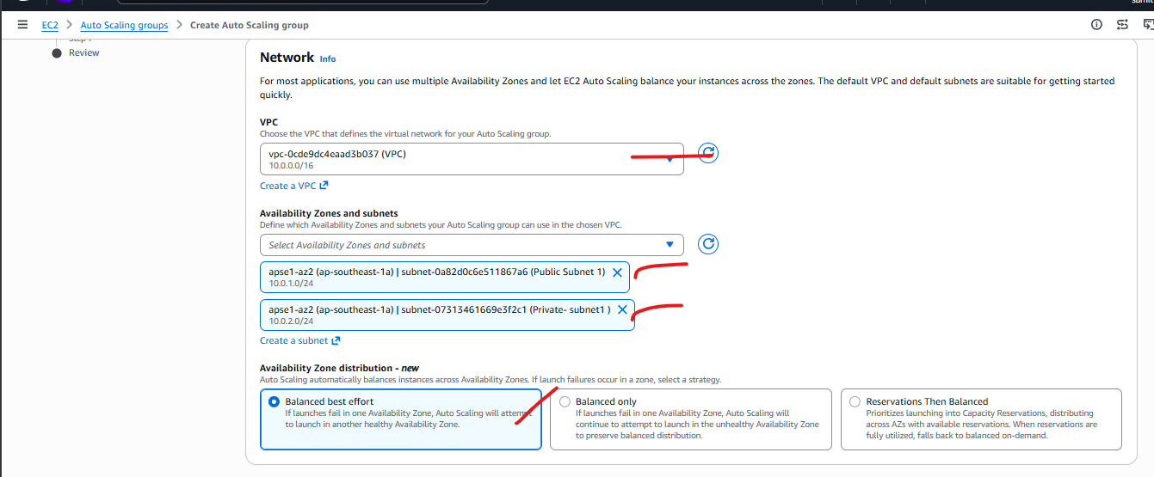
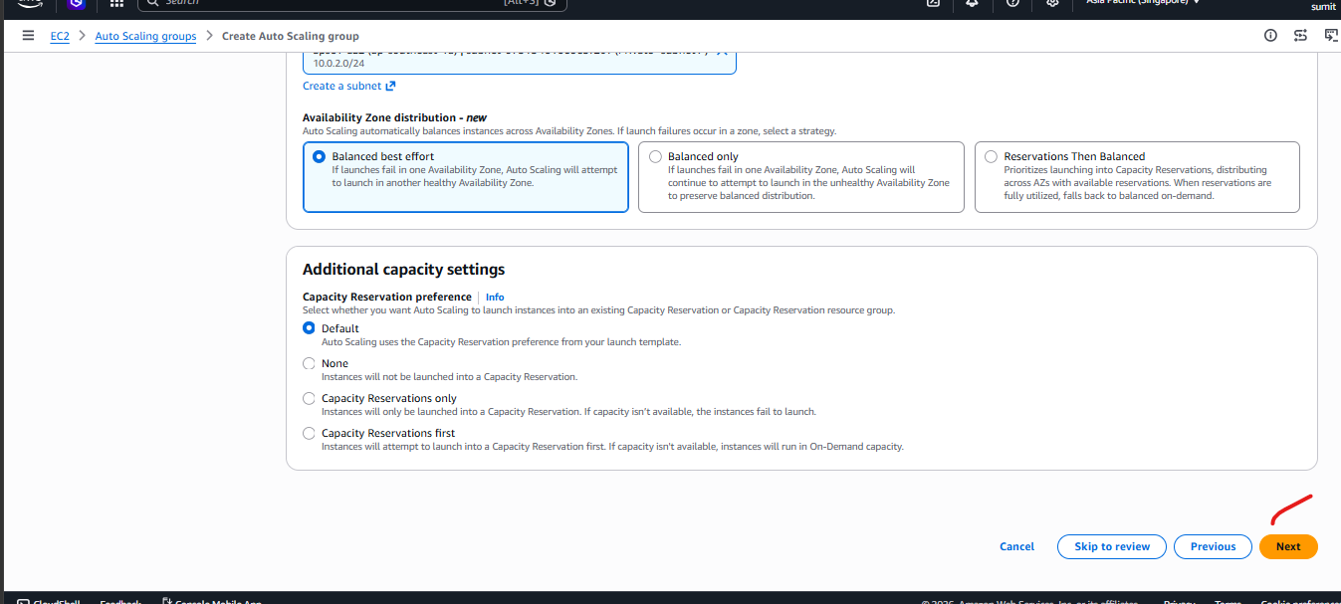
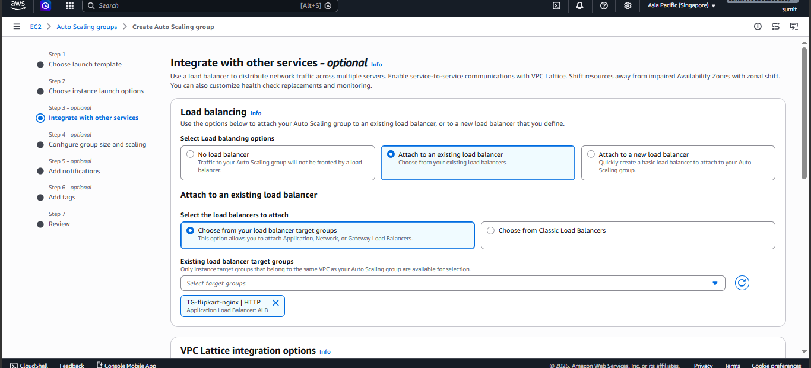
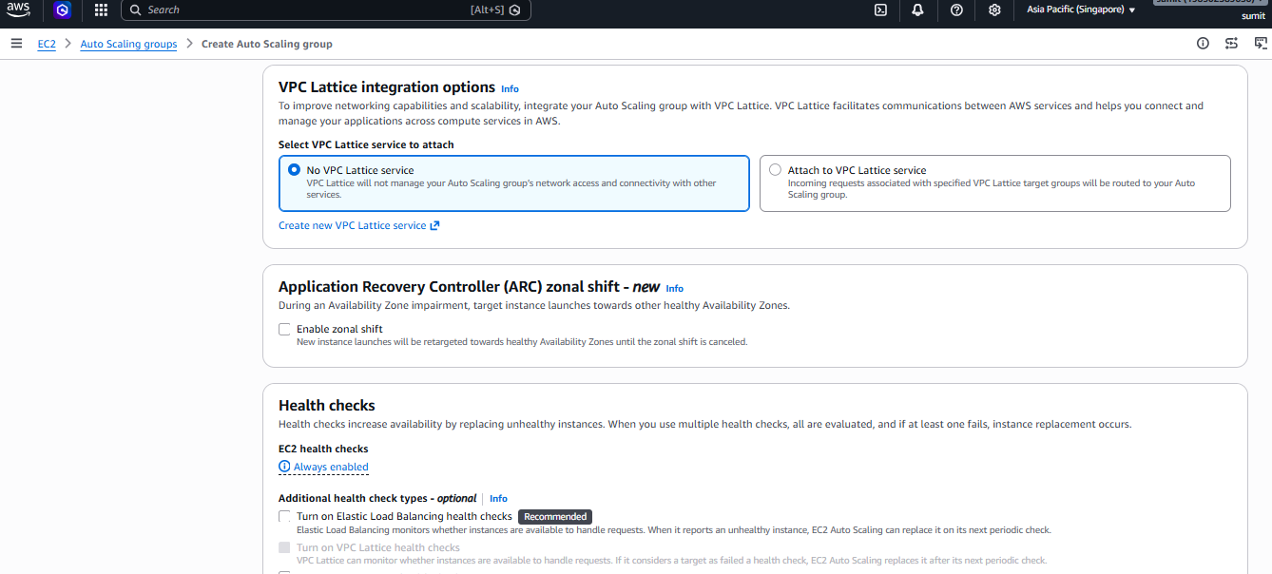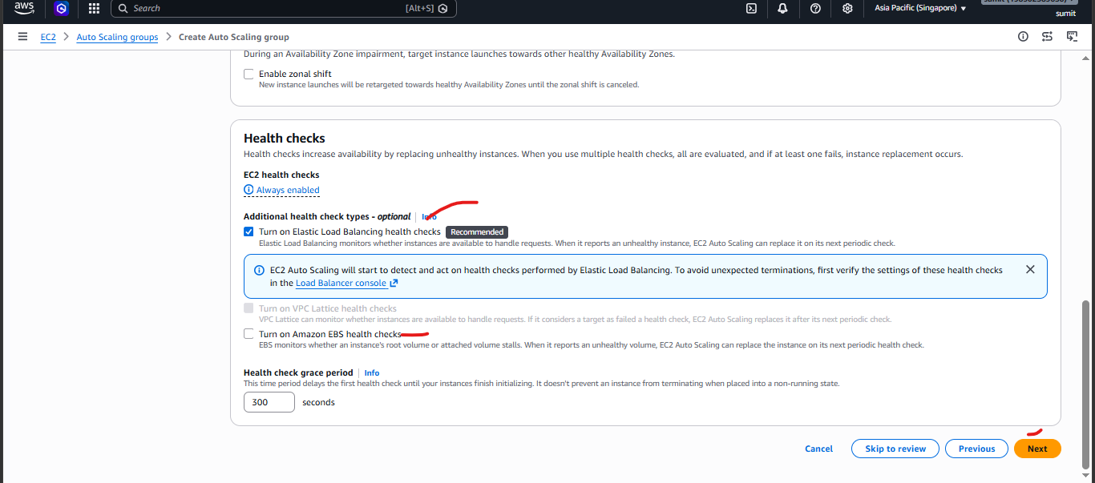
Think of a hotel:
- Minimum Capacity = Minimum staff that must always be on duty.
- Desired Capacity = Number of staff needed on a normal day.
- Maximum Capacity = Maximum staff the hotel can call in during peak season.
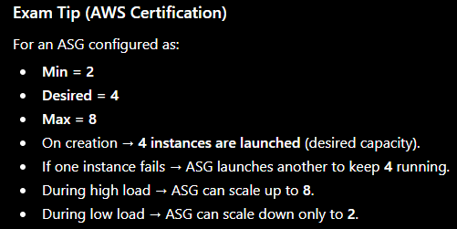

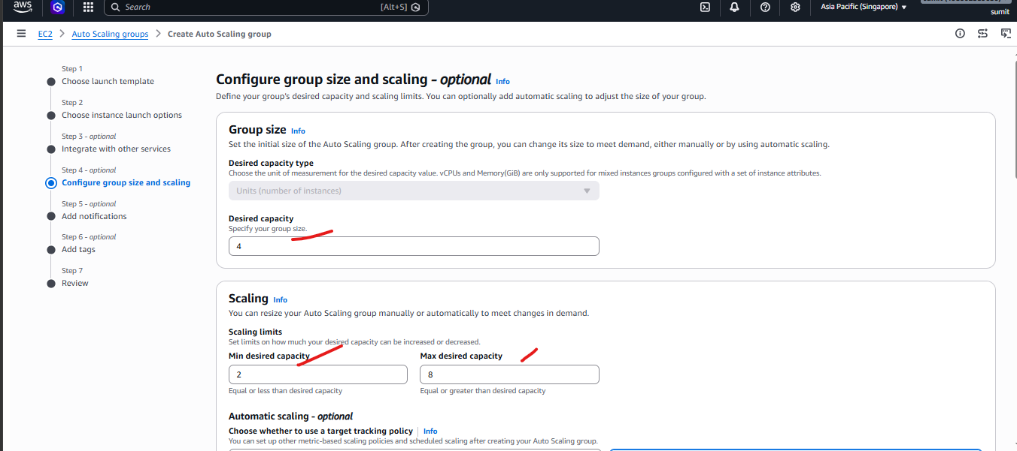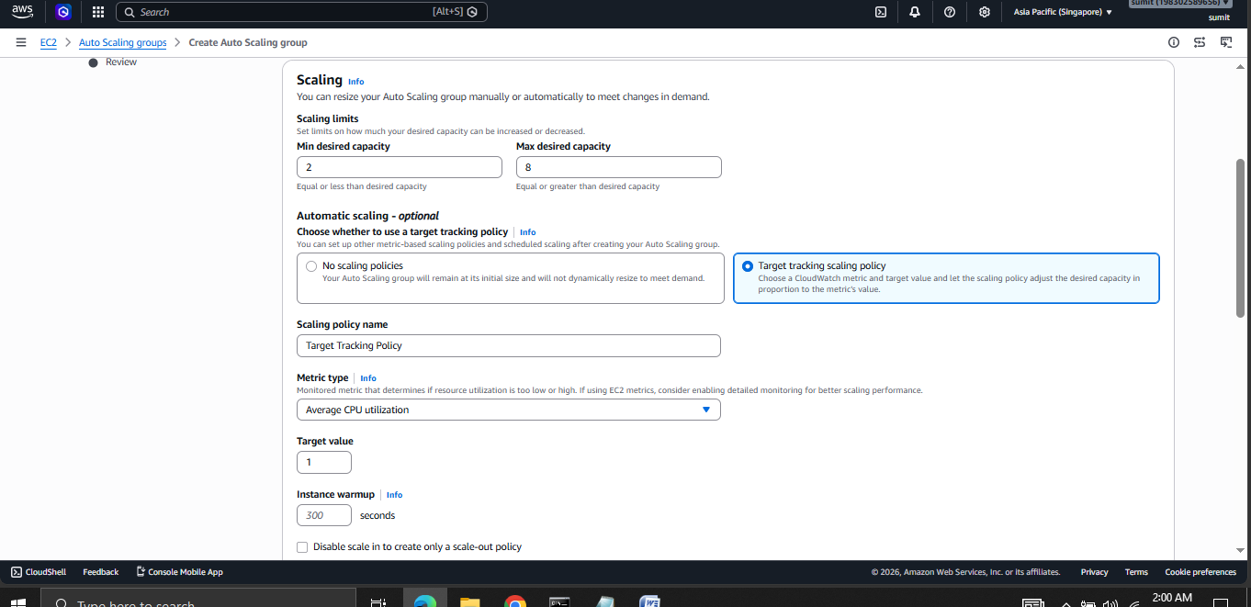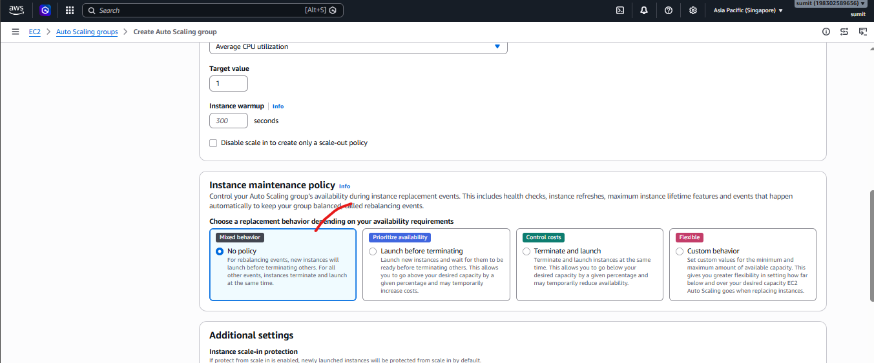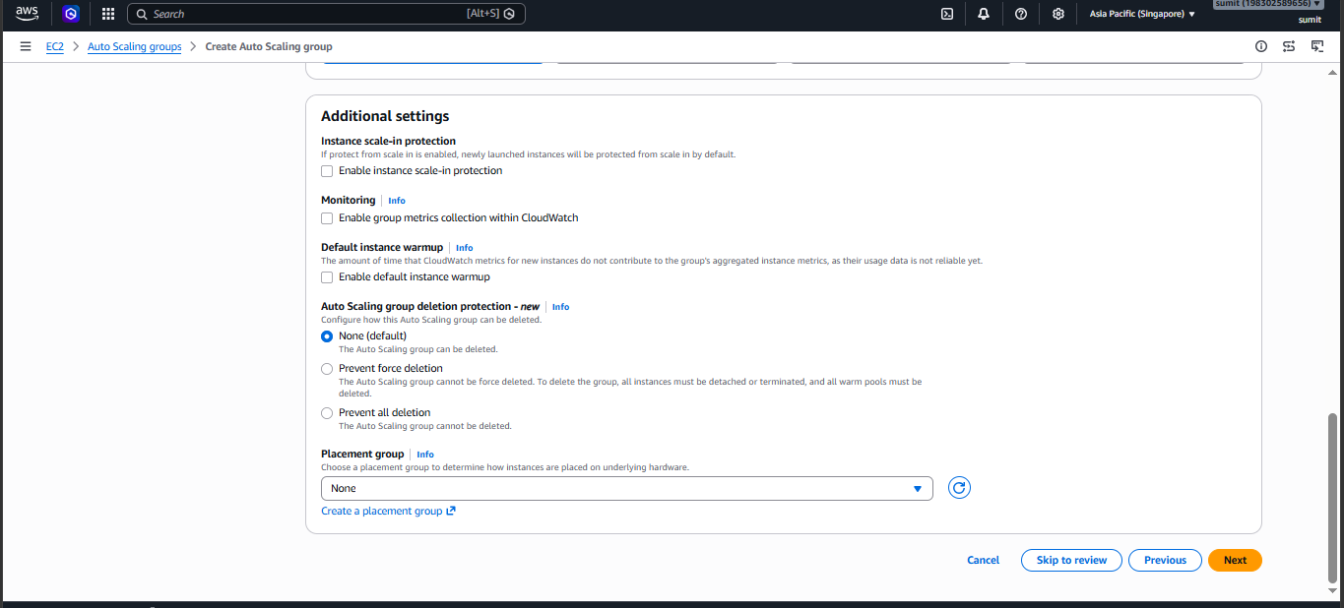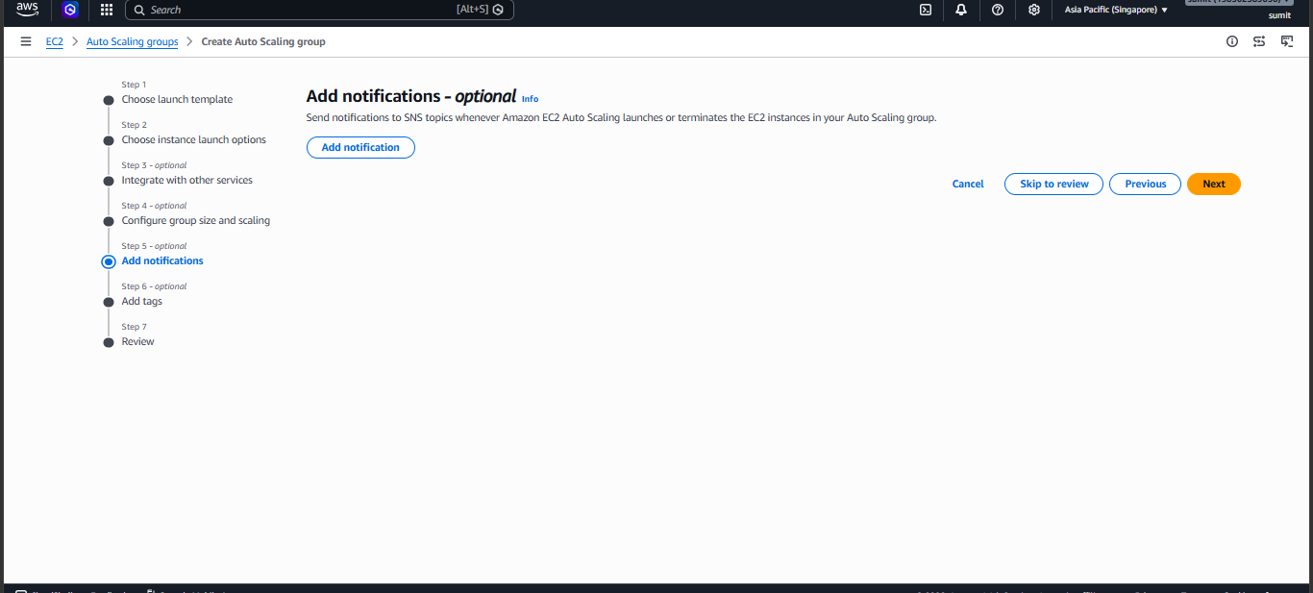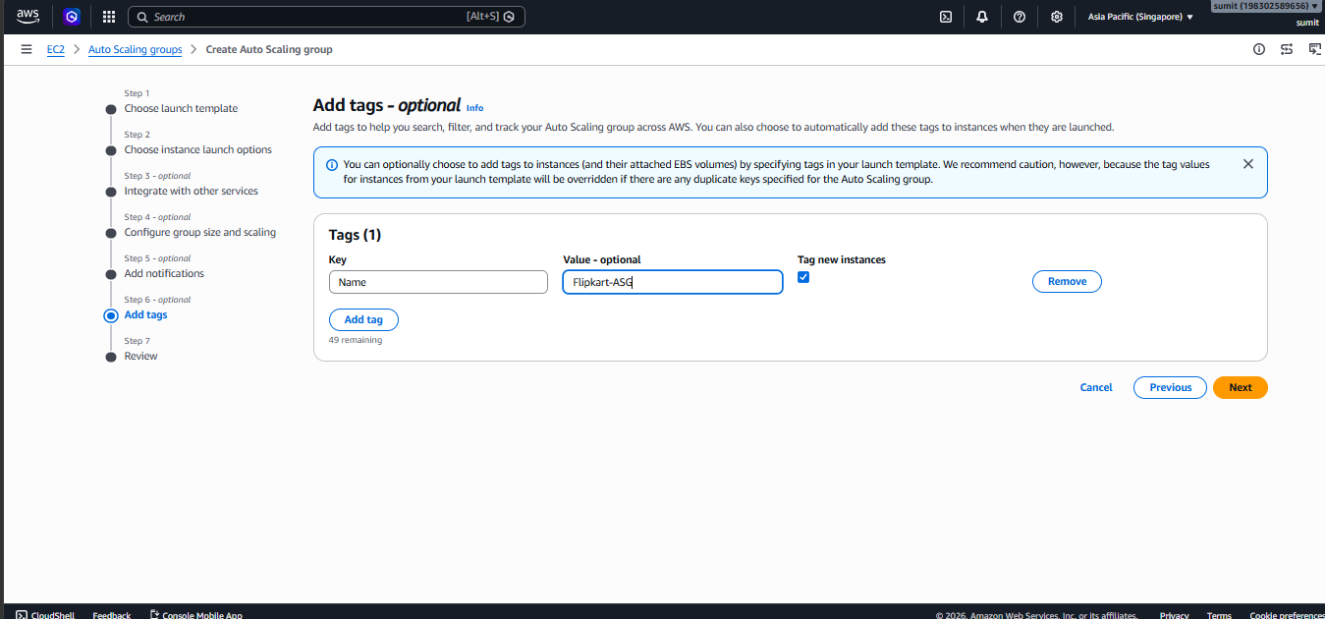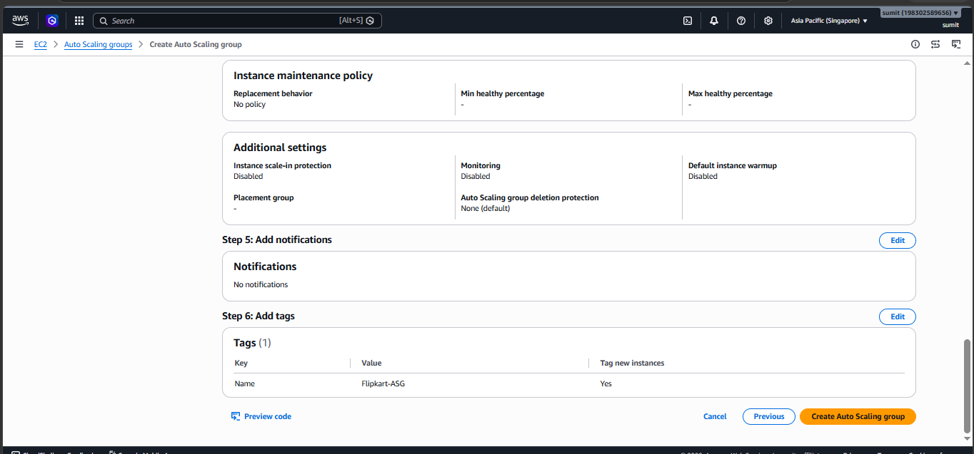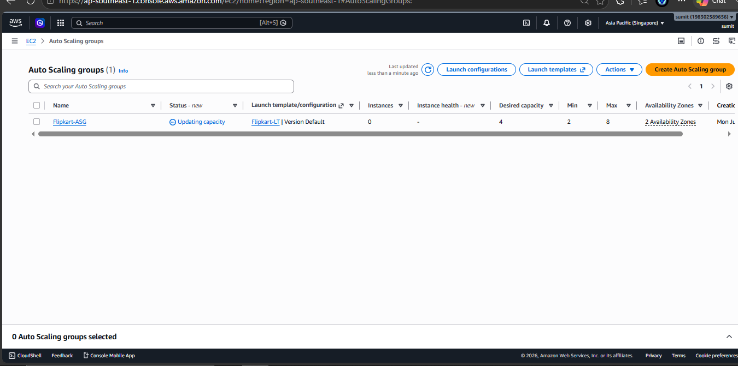

Before CPU usage <1% 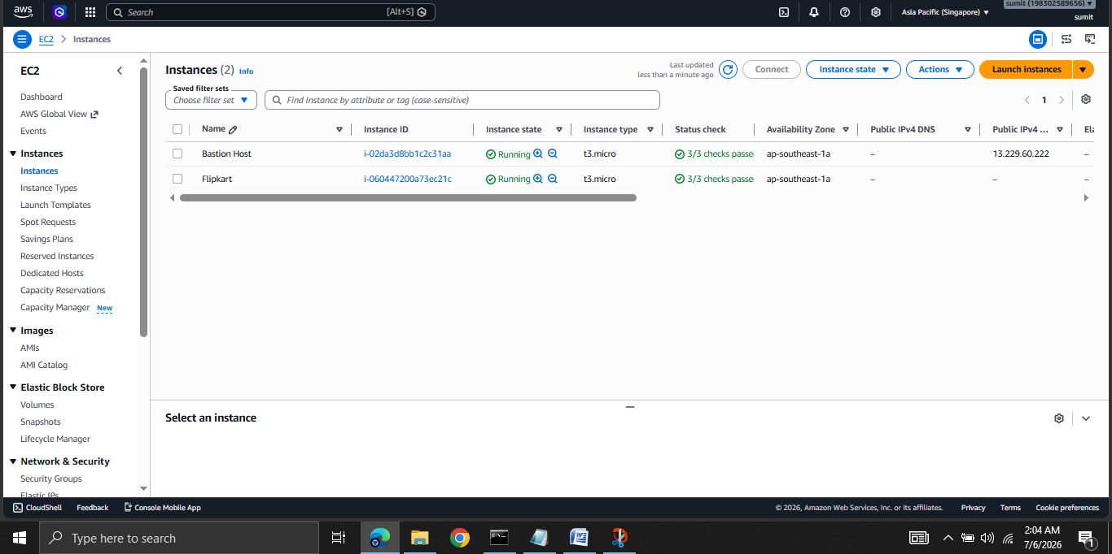

After CPU usage >1%
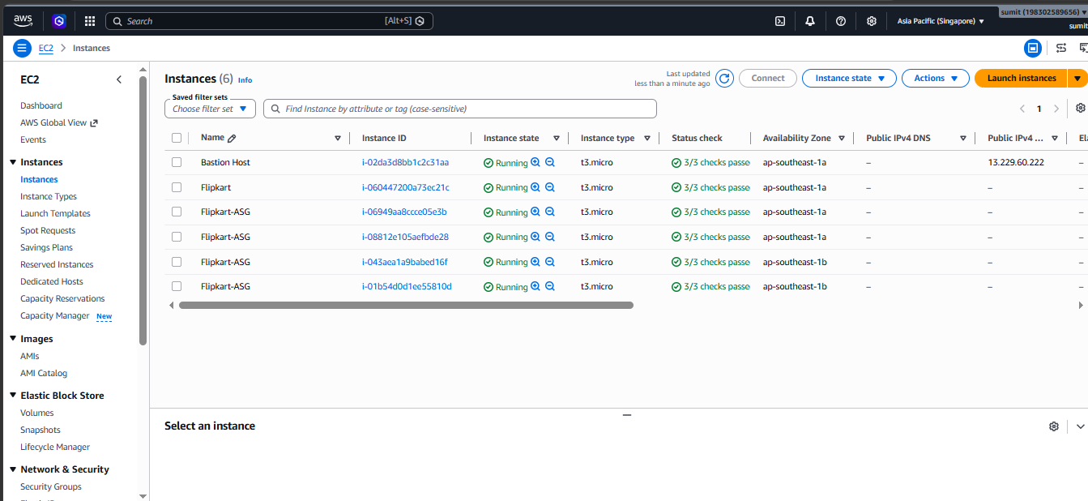

Now change condition cpu <30% , currently cpu is not consuming that much memory .
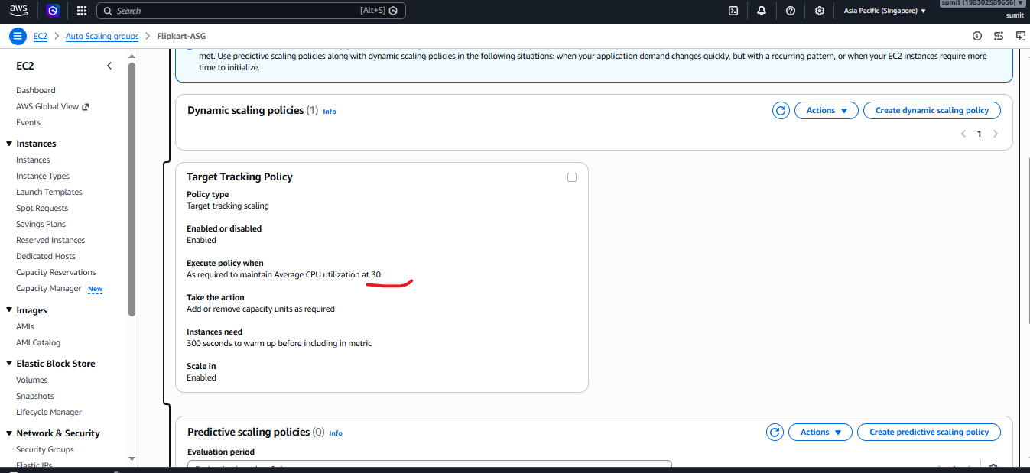

So it will revert back to Desired capacity which is 2.
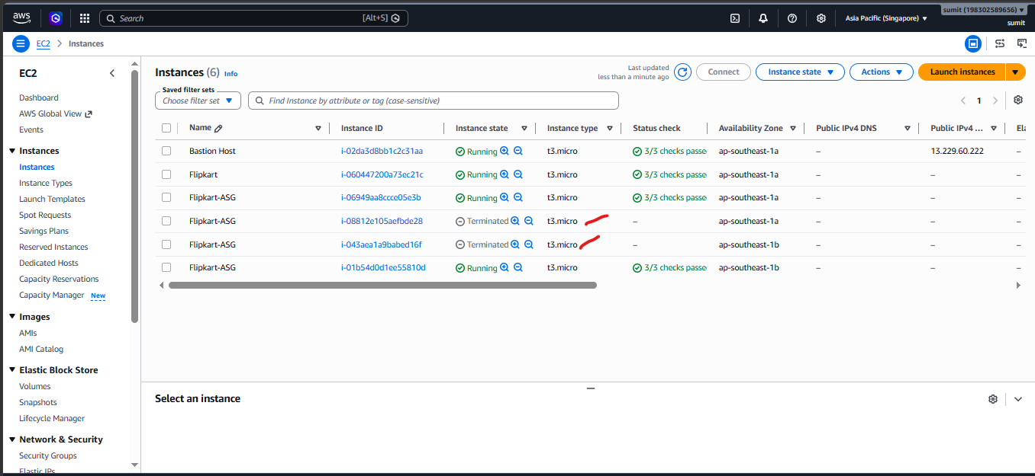

Before
